Kali practical’s:
Ping:
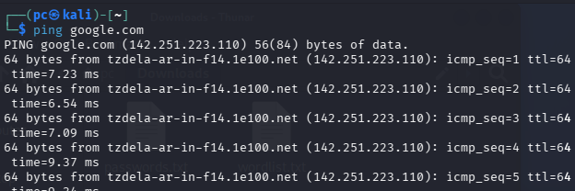

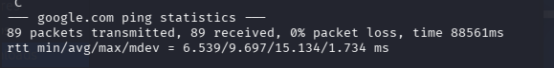

Ifconfig:
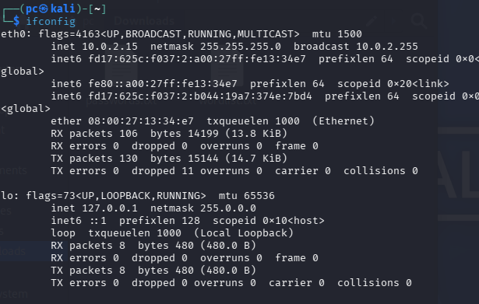

Whois:
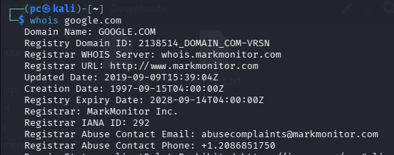

John the ripper:
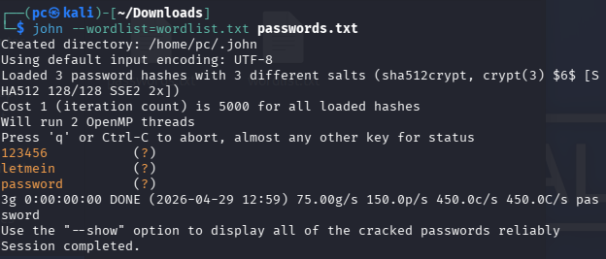

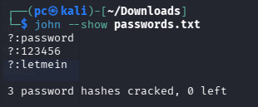

Ophcrack:
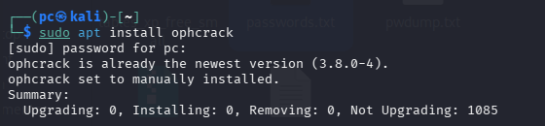
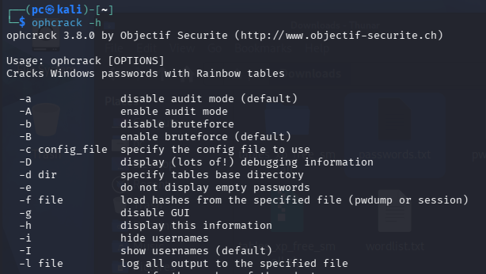

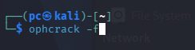

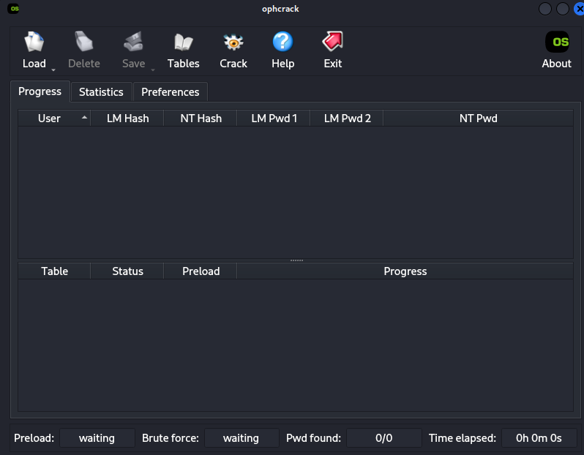
Load hash : Load > PWDUMP file > select your pwdump.txt
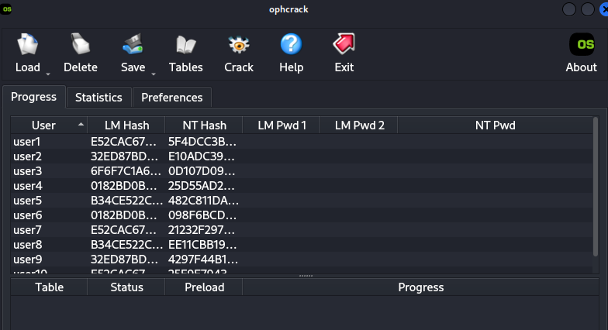
Download rainbow table from : https://ophcrack.sourceforge.io/tables.php > download xp free small (380 mb)
Load rainbow tables : Tables > xp free small > click install > select directory containing xp tables
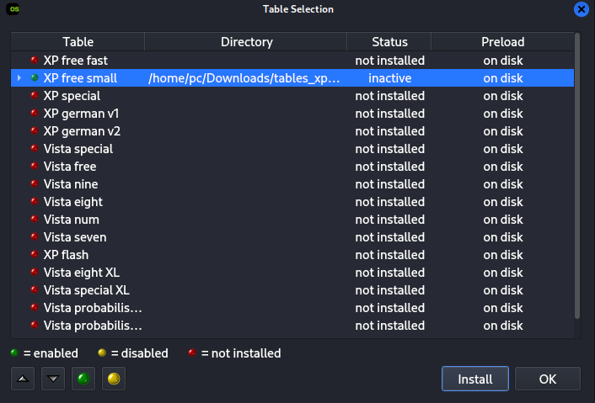
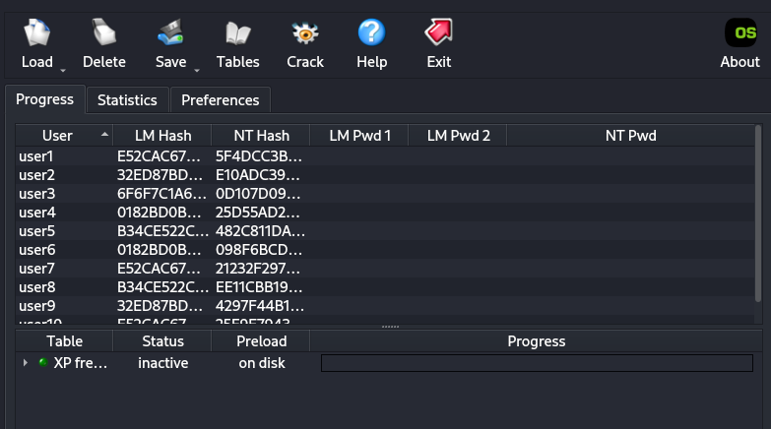
Once the table is loaded click crack :
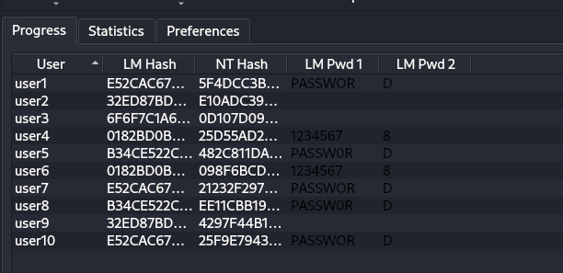

Nmap tutorial :
- I vm settings :
Network > bridged adapter :
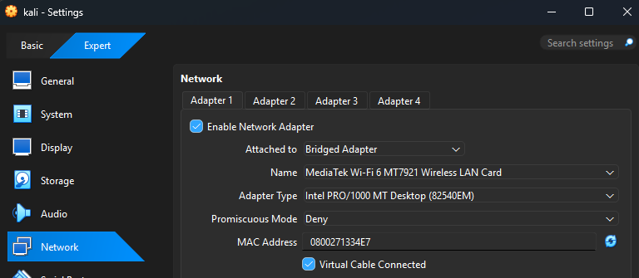
Note : Now you are on your home network and will be able to use nmap to analyze machines on it.
Use ip add to find your home network :
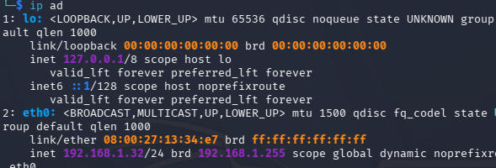

"nmap -sP" does a host discovery (ping sweep):

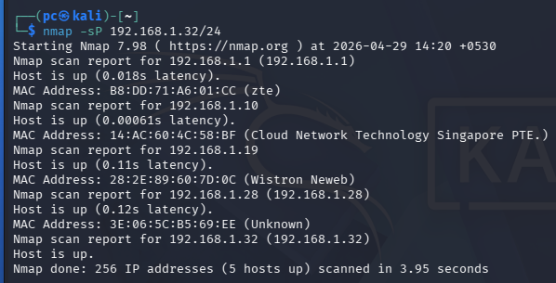
Note: 5 host are up
- Check for open ports, once you know which ip addresses are active, find what ports they are listening on.

Tcp scan :
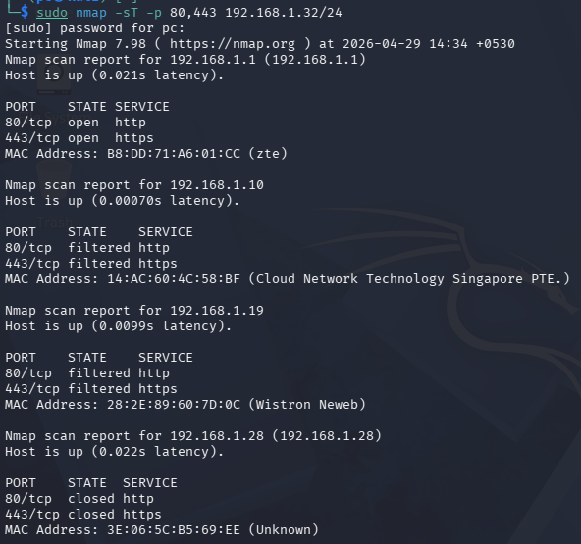

Note : state : open means port is open , closed means port is closed , filtered indicates that a firewall or filtering mechanism is blocking, dropping, or ignoring packets sent to a port, preventing the system from confirming whether the port is open or closed.
We have analysed that port 80 and 443 are open on machine 192.168.1.1
Now we will run a full tcp scan on 192.168.11:
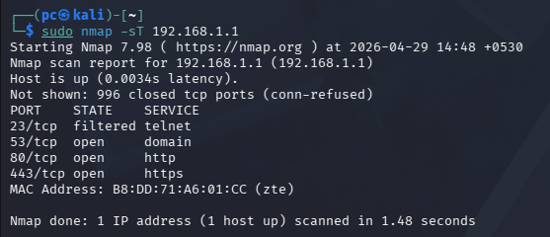
We have analysed all the ports on 192.168.1.1
- Detecting operating system of remote machine:
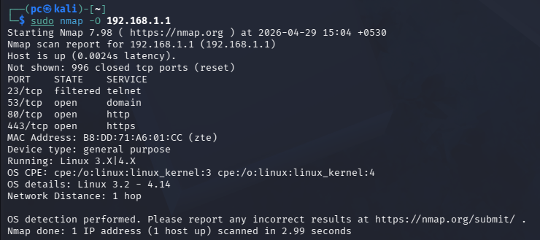
We have analysed that 192.168.1.1 is running linux.

Burpsuite:
Installation:
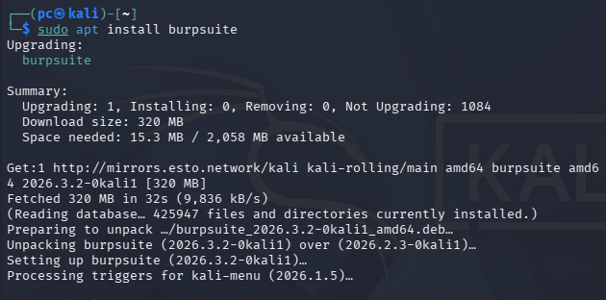
Check version :
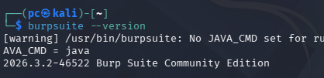
Open burpsuite:

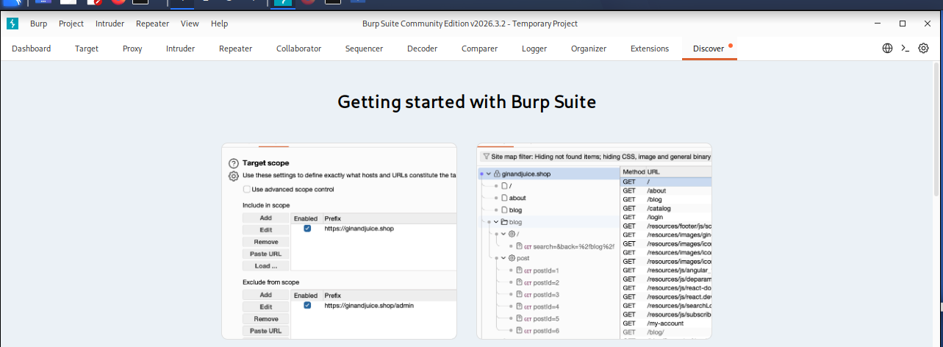

Now : proxy > open browser
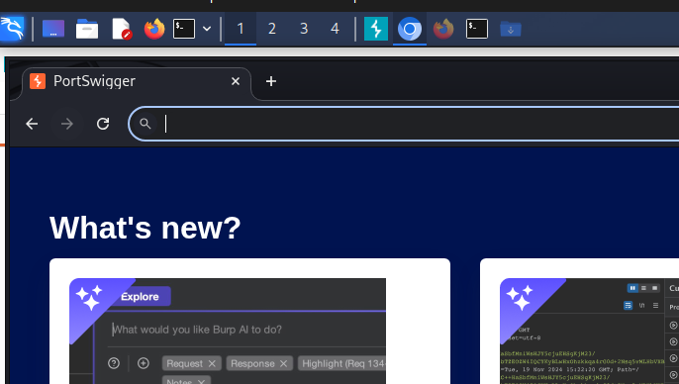

Search for owasp juice box


In burpsuite go to proxy and turn interceptor on:
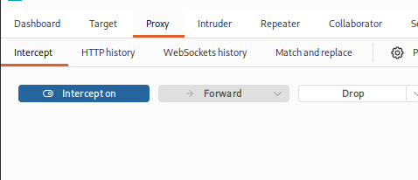

In juice shop :
Go to accounts > not yet a customer > user registration
Fill your details :
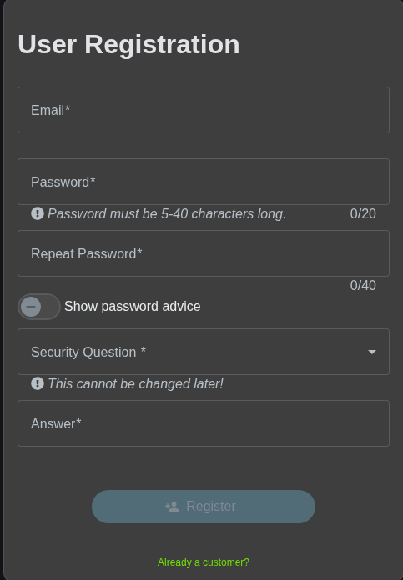

Forward requests in burpsuite:
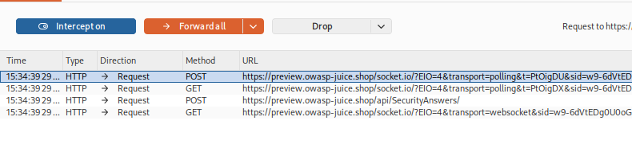
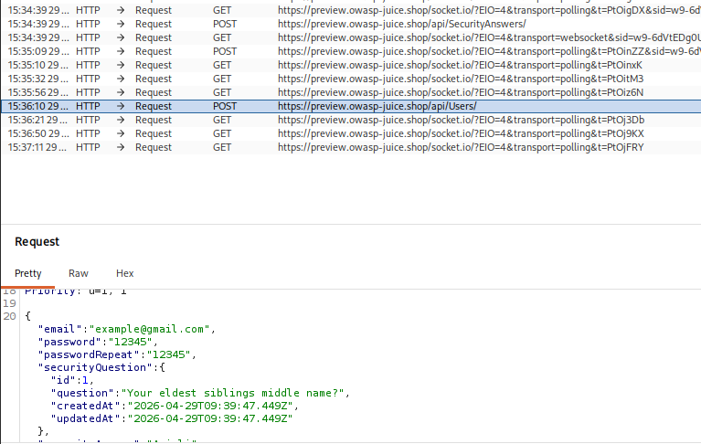
Now in burp we have intercepted the request for creating a new account.
We will now modify it and change the password in burp:

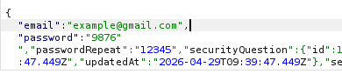
We have successfully used burp proxy to modify message.

Demonstrate use of gpg utility for signing and encrypting purposes.
Generate key pair :
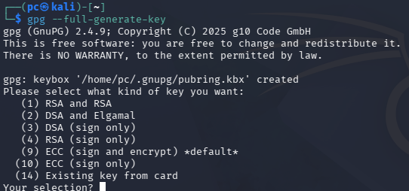
Choose:
- RSA & RSA
- Key size: 2048
- Enter name, email, password
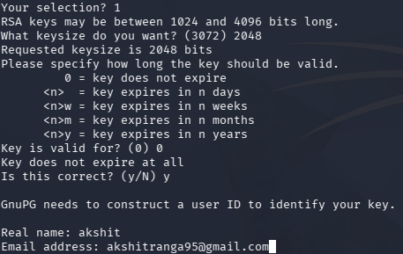
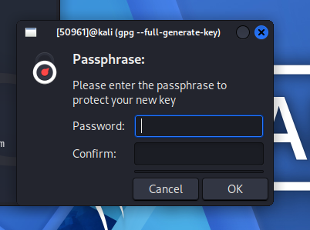

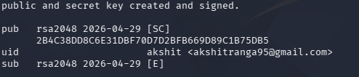
Step 3: List Keys
gpg --list-keys

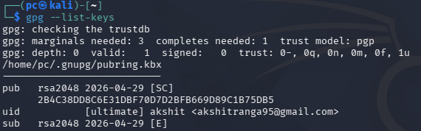
Step 4: Signing a File
Create file:
echo "Hello Secure World" > file.txt
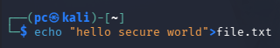
Sign file:
gpg --sign file.txt

You will be asked for paraphrase:
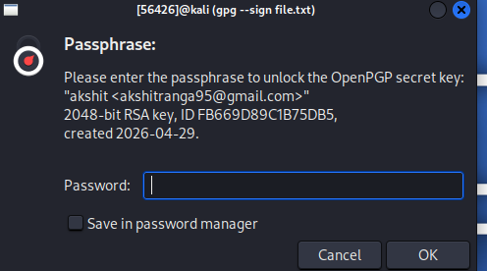
Step 5: Verify Signature
gpg --verify file.txt.gpg
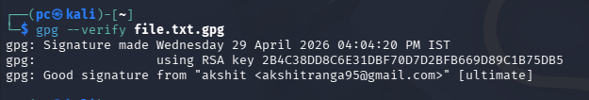
Step 6: Encrypt a File
gpg --encrypt --recipient "user@email.com" file.txt
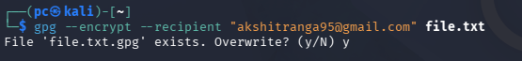
Step 7: Decrypt File
gpg --decrypt file.txt.gpg

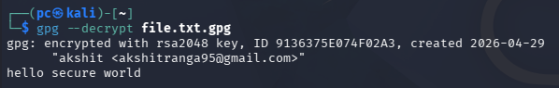

We have decrypted the file

